Angles Made By a Transversal

Name_____________________________________ Date_____________________ Period____________

Find all possible angles and name the type of the two angles shown.

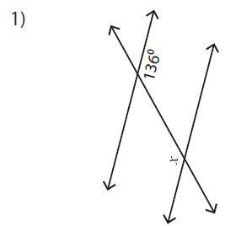 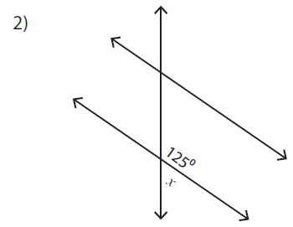 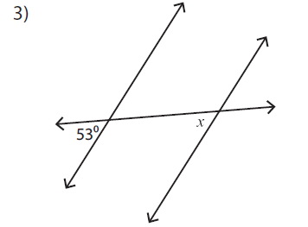 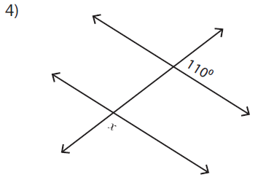

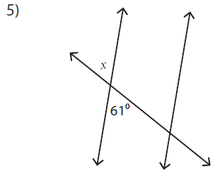 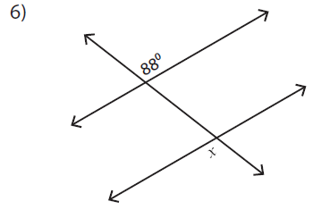 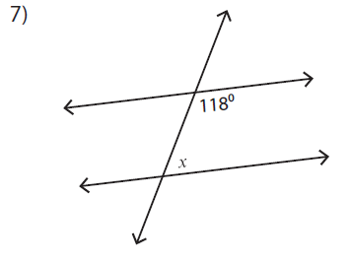 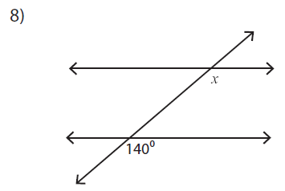

Angles Made By a Transversal

Name_____________________________________ Date_____________________ Period____________

Find all possible angles and name the type of the two angles shown.

   

   